# Lab 4. Dynamic Routing EIGRP with Authentication & Load Balancing

# Topology

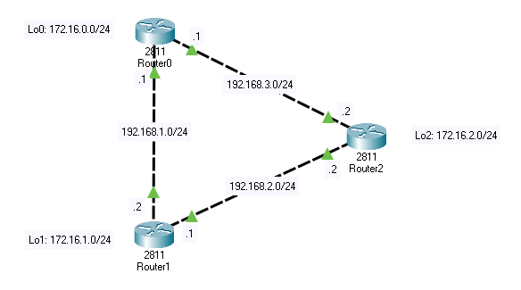

# Interface config

Router(config)#hos R2

R2(config)#int fa0/0

R2(config-if)#ip address 192.168.2.2 255.255.255.0

R2(config-if)#no shut

R2(config-if)#ex

R2(config)#int fa0/1

R2(config-if)#ip address 192.168.3.2 255.255.255.0

R2(config-if)#no shut

R2(config-if)#ex

R2(config)#int loopback 2

R2(config-if)#ip address 172.16.2.1 255.255.255.0

R2(config-if)#ex

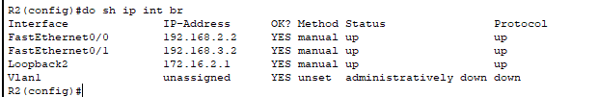

***\*R0 and R1 are the same***

# 

# EIGRP config

R0(config)#router eigrp 100

R0(config-router)#network 172.16.0.1 0.0.0.0

R0(config-router)#network 192.168.1.0 0.0.0.255

R0(config-router)#network 192.168.3.0 0.0.0.255

R0(config-router)#ex

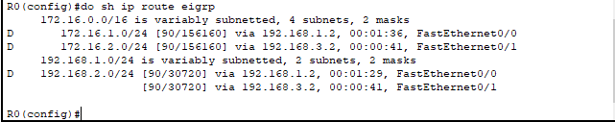

# Authentication

R0(config)#key chain R0Chain

R0(config-keychain)#key 1

R0(config-keychain-key)#key-string R0Key1

R0(config-keychain-key)#accept-lifetime 09:00:00 Apr 30 2024 infinite

R0(config-keychain-key)#send-lifetime 09:00:00 Apr 30 2024 09:01:00 Apr 30 2024

R0(config-keychain-key)#ex

R0(config-keychain)#key 2

R0(config-keychain-key)#key-string R0Key2

R0(config-keychain-key)#accept-lifetime 09:00:00 Apr 30 2024 infinite

R0(config-keychain-key)#send-lifetime 09:00:00 Apr 30 2024 infinite

R0(config)#int range fa0/0 - 1

R0(config-if)#ip authentication mode eigrp 100 md5

R0(config-if)#ip authentication key-chain eigrp 100 R0Chain

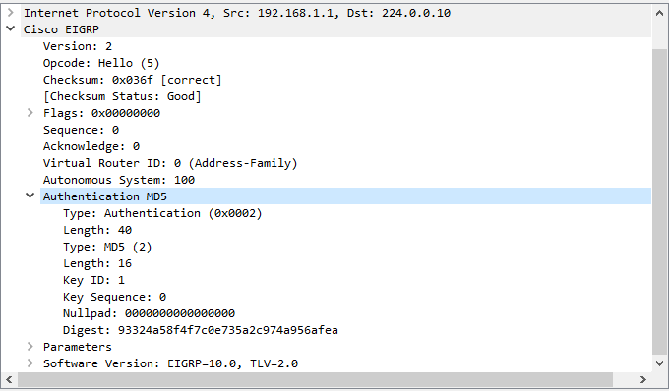

# Load Balancing

WHERE ?

0 biết làm :D

Hay lười :v

Cái gì cũng biết 👀